Form Elements - Syntax

The form can be created using <form>...</form> tag of HTML.
The <form> tag has the below attributes:
- method: Defaults to HTTP "get" method of submission to the server. To use HTTP "post", use method="post"
- action: The URL to which the form data has to be submitted
- target: Specifies if the submitted result will open in the current window, a new tab, or on a new frame
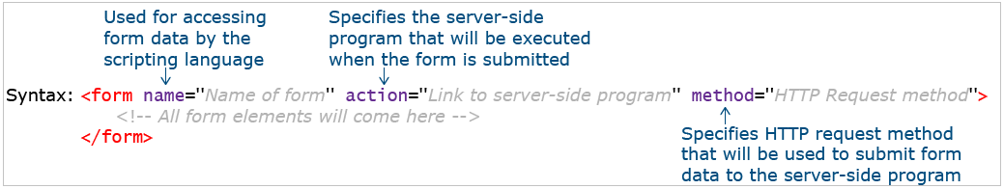
Form Input Elements - Syntax

The form input element is used to collect details from the user.
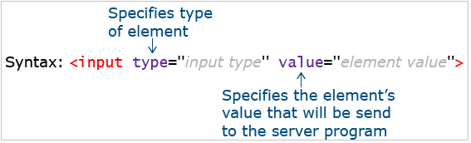

The table below lists the various types of input elements.
The possible value of "type" | Description
text | Creates textbox
password | Creates textbox that accepts the only password
checkbox | Creates checkbox
radio | Creates a radio button
button | Creates button
submit | Creates a button that submits values of all form elements to the server
reset | Creates a button that resets values of all form elements to their default value
image | Creates a graphical version of a button
file | Creates control to upload the file to the server
hidden | Creates a hidden text field
email | Creates textbox that accepts only valid email id
number | Creates spinbox that accepts only whole numbers
range | Creates a range slider
search | Creates a search bar
URL | Creates textbox that accepts only valid URL
color | Creates color picker
date | Creates date picker to select date
month | Creates date picker to select a month
week | Creates date picker to select week

Input Types - Text, Password, Email and Number

Let us learn some of the basic input types of HTML form and understand their implementation in short.
Input type - text:
A single-line text field. The value attribute defines the value of the input field.
- Name: <input type="text" value="">
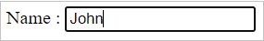

Input type - password:
An input field can be used to enter a password.
- Password: <input type="password">
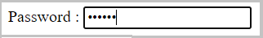
Input type - email:
- An input field that accepts email addresses.
- It has in-built validation for an email.
- Email-Id: <input type="email">
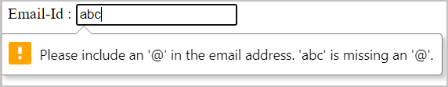
Input type - number:
- Defines an input text box, where the user can enter only numerical input.
- Gives an error on form submission if the value entered goes beyond the min and max limits and includes built-in validation to reject non-numerical values.
- Attributes min and max can be used to define a boundary and step attribute value which can be used for defining the difference between consecutive numbers.
- Age: <input type="number">
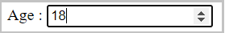

Input Types - Checkbox, Radio and File
Input type - checkbox:
- Defines a checkbox.
- The checked attribute checks that particular checkbox value.
- Also, multiple checkboxes can be checked at a time.
- Hobbies: <input type="checkbox" checked> Reading
- <input type="checkbox" checked> Singing
- <input type="checkbox" > Dancing
Input type - radio:
- Defines a radio button.
- The name attribute specifies the associated name of that radio button.
- Radio buttons in a group should have the same name.
- Gender: <input type="radio" name="gender" checked value="Male"> Male
- <input type="radio" name="gender" value="Female"> Female
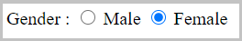
Input type - file:
Creates a control to upload a file to the server.
- Select a file: <input type="file">

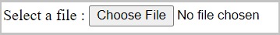

Input Types - Button and URL
<button> element:
- Defines a clickable button that can be used to submit the form.
- The button can be of 3 types:
  - submit (default with <button> tag)
  - reset (to reset the form)
  - button (just a clickable button)
- <button type="submit">Raise your query</button>
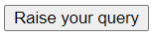
Input type - URL:
Defines a text input that can capture any input value starting with http:// or https://. If there is a pattern mismatch, it shows an error on form submission.
- Enter the website URL: <input type="url">
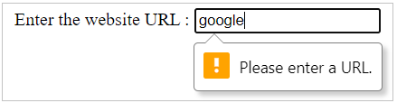

Input Types - Textarea and Hidden

<textarea> element:
- Defines a multi-line text field.
- It is not possible to set a default text using the value attribute. Hence, default text can be placed into <textarea>…</textarea> tag.
- Write your comments: <textarea rows="4" cols="10" >Default value</textarea>
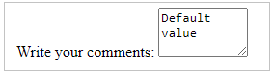

Input type: Hidden:
You may want to submit supplementary data (such as users' language of user input) to the server, without any user interaction.
This can be done using a hidden element.
- <input type="hidden" name="Language" value="English"/>

Label:
The <label> element is used to associate a text label with a form <input> field. The label is used to tell users the value that should be entered in the associated input field.
Additionally, the "for" attribute of the label can point to the "id" of input control. This ensures the cursor focuses on the respective input control on the click of the label.
It also enhances the usability, by allowing the user to toggle the control by clicking on text written within <label>…</label> tag.
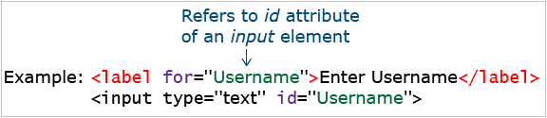
Color Picker and Date Picker

We have various picker-elements in HTML forms such as color-picker and date-picker elements.
Let us see them in detail.
Input type - color:
Defines a color picker.
- Choose a color: <input type="color">
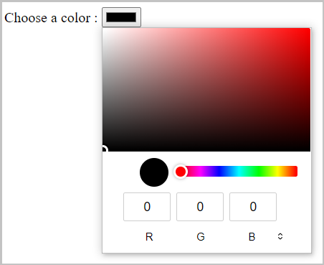
Input type - date:
Creates a date-picker which is used to collect dates.
- Date of Birth: <input type="date">
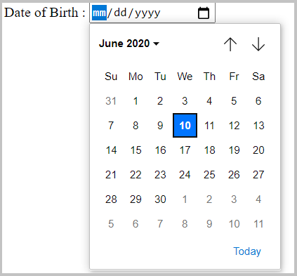
Input type – datetime-local:
Defines a date-time picker, where the user can pick a date as well as time
- Choose a date and time: <input type="datetime-local"/>
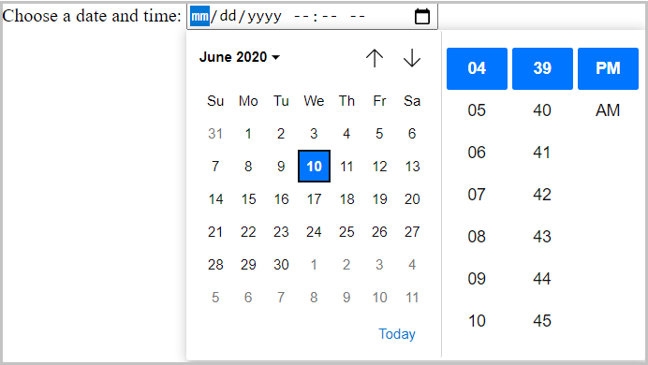

Input type – week:
Defines a date picker, where the user can pick a week.
- Select a week: <input type="week"/>
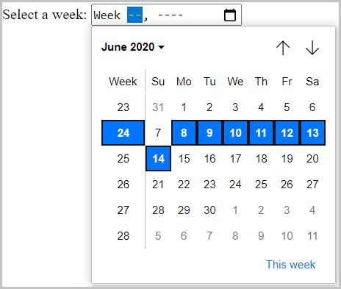
Input type – month:
Defines a date picker, where the user can pick a month.
- Select a month: <input type="month"/>
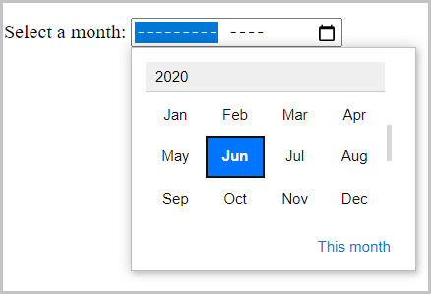

Select and Datalist Elements
We have <select> and <datalist> elements in HTML which helps to collect input data from user as a drop-downs.
Let us see them in detail:
<select> element :
- Defines a drop-down list.
- The "multiple" attribute can be used for having a multi-select dropdown menu.
- Country code: <select >
- <option value="">-- Please choose a country code --</option>
- <option value="+213">+213</option>
- <option value="+91">+91</option>
- <option value="+244">+244</option>
- <option value="+61">+61</option>
- <option value="+973">+973</option>
- </select>

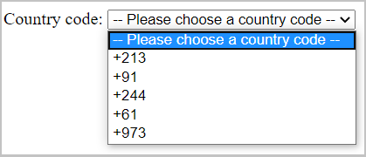

datalist> element:
- Defines a set of pre-defined options available to choose for an <input> element.
- In the below example list attribute holds lists of possible options, the value assigned to the list attribute of the input element and id attribute of datalist attribute should be the same and the value sent to the server should be assigned to the option element value attribute.
- Country: <input list="countries">
- <datalist id="countries">
- <option value="India">
- <option value="France">
- <option value="Singapore">
- <option value="Thailand">
- <option value="United Arab Emirates">
- <option value="United States of America">
- </datalist>

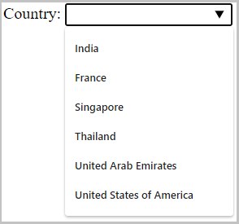

Note: <select> allows the user to select from some pre-defined options.
Whereas, for the <datalist> element, even though it is suggested to select from the given options, the user can actually enter the data to the input field as any other input field.

Range, Meter, Progress

Let us see some other input elements in HTML where the data can be collected from the user as a slider.
Input type – range:
Defines a range slider, where the user can select input.
- Volume: <input type="range"/>
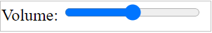

Meter:
Can be used to represent a scalar measurement within a known range.
- Disk usage: <meter min="0" max="100" value="50"></meter>

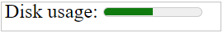
Progress:
Can be used to represent the progress of a task.
- Task completed: <progress min="0" max="100" value="50">50 of 100</progress>
Note: <progress> can be used to mark up the completion rate/degree of progress of an "in progress" task through a progress bar.
Whereas, <meter> is used to represent a gauge or to represent a measurement in a known scale.
Output:
Displays the output of user input.
For example, consider the below code snippet:
- <form oninput="result.value=parseInt(a.value)+parseInt(b.value)">
- <input type="number" id="b" name="b" value="10" /> +
- <input type="number" id="a" name="a" value="10" /> =
- <output name="result" for="a b">20</output>
- </form>
The 'oninput' attribute carries the logic of generating the output, and the 'for' attribute of <output> tag specifies the control for which output has to be calculated.
The above-given code would populate two input fields on the web page and the sum of the values of these two input fields is generated dynamically based on user activity on this page.
The output of the above code snippet will be as shown below:
Note: A disabled attribute can be used with any input type to restrict user interaction.
For example, a button can be made non-clickable, Checkbox can be made non-selectable.
The output may vary for some input elements according to the browser.
Problem Statement:
Consider the below Signup page of Hussain's Shopping application.
Add the form elements in the below-given code to populate the output as below:
Signup.html
- <!DOCTYPE html>
- <html>

- <head>
- <meta name="keywords" content="Online, Shopping" />
- <title>Hussian's Shopping</title>
- </head>

- <body>
- <header>
- <h1>Sign Up!</h1>
- </header>
- <article>
- <!-- Add form here-->
- <br /> <br /> <br /> <br />
- </article>
- <footer>
- <nav> About Us | Privacy Policy | Contact Us | FAQ | Terms & Conditions </nav> Copyright &copy; 2018 | Giri
- </footer>
- <aside> Like and Connect with us FB Twitter g+ </aside>
- </body>

- </html>

Expected Output:
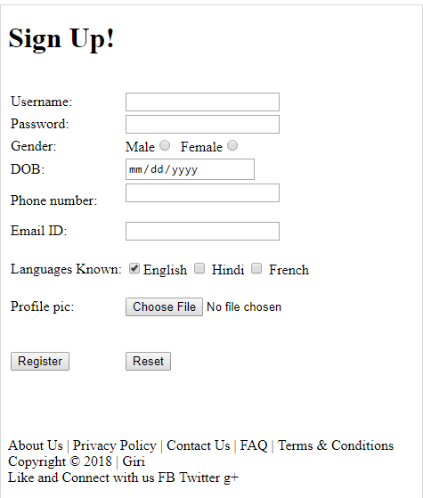

Problem Statement:
Consider the below Rating Page of Hussain's Shopping Application.
Add the form elements range and meter in the below-given code to populate the output as below:
Rating.html
- <!DOCTYPE html>

- <html>
- <head>
- <title>Hussain's Shopping</title>
- <meta name="keywords" content="Online, Shopping"/>
- </head>

- <body>
- <header>
- <nav>
- <a href="Login.html"> Login </a> |
- <a href="Signup.html"> SignUp </a> |
- <a href="TrackOrder.html"> Track order </a>
- </nav>
- <h1>Track your order</h1>
- </header>

- <article>
- <h2>Rate your shopping experience:</h2>

- <form oninput="M1.value = parseInt(R1.value);M2.value = parseInt(R2.value);M3.value = parseInt(R3.value);M4.value = parseInt(R4.value);">
- Delivery of product on time : <!-- Add range element with id="R1" and meter element with id="M1" --><br/><br/>
- Product quality : <!-- Add range element with id="R2" and meter element with id="M2" -->60 of 100</meter><br/><br/>
- How friendly the site is : <!-- Add range element with id="R3" and meter element with id="M3" -->20 of 100</meter><br/><br>
- Were you able to find the product which you were looking for?: <!-- Add range element with id="R4" and meter element with id="M4" --><br/><br/>
- </form>
- </article>

- <footer>
- <nav> About Us | Privacy Policy | Contact Us | FAQ | Terms & Conditions </nav>
- Copyright &copy; 2018 | Giri
- </footer>

- <aside>
- Like and Connect with us FB Twitter g+
- </aside>

- </body>
- </html>

Expected Output:
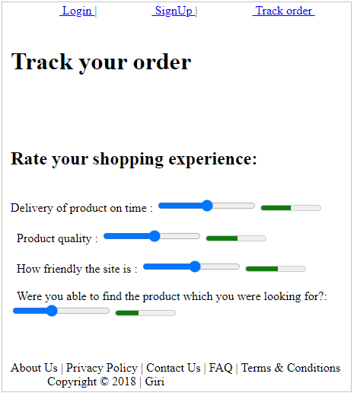

Attributes of Input Elements

The following are some of the attributes which can be used with HTML input elements.
- Placeholder
- Pattern
- Min
- Max
- Step
- Required
- Multiple
- Form-override
Let us see each of them in detail.
Placeholder:
The placeholder attribute specifies a value that appears in the textbox as below:
- First name: <input type="text" placeholder="Enter your first name"/>

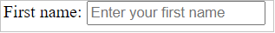
Pattern:
The pattern attribute creates a custom pattern validator.
The value entered by the user is checked for validity against a specified pattern.
If the user input value does not match with a specified pattern, an error message appears.
- Username: <input type="text" pattern="[A-Za-z]"/>
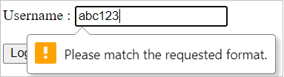
Min, Max, and Step:
The following are some of the attributes which are used only with range and number input types
- min: Specifies a minimum acceptable value.
- max: Specifies maximum acceptable value.
- step: Specifies a difference of consecutive values when the user uses the range/number input element.
- Job experience: <input type="number" min="2" max="10" step="1"/>
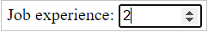
Required:
The required attribute specifies that user input is a must.
If the user does not enter any value in the input field which is associated with this attribute, a default error message appears on the screen.
- Username: <input type="text" required/>
- Username: <input type="password" required/>
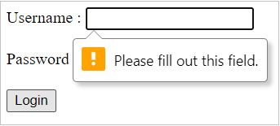

Multiple:

The multiple attribute value allows the user to enter/select/upload more than one value.
- <input type="file" multiple/>
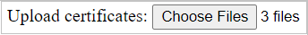

Autocomplete and Autofocus
HTML has autocomplete and autofocus attributes for the below-mentioned functionalities.
autocomplete:
It allows the browser to predict user input value.
When the user starts typing, the browser displays possible options, based on earlier typed values.
Possible values of autocomplete are on and off where the default value is "on"
autofocus:
Specifies that an element should automatically get focus when a web page loads.
Example:
- Email:<input type="email" autocomplete="on"/> <br/>
- Contact: <input type="number" autofocus/><br/>
- <input type="submit"/>

Hidden:
In a web page, when an element is not directly relevant to the page's current state, it's a good choice to hide it.
The hidden attribute is used for this requirement.
Possible values are " " (Empty string) or hidden.
For example, the below-given input field for the language will not be shown to the end-user.
- <input name="language" value="English" hidden >

